**Use cases testing:**

1. **Normal User Registration**

This test case is for the registration of the new members, many scenarios are tested below, and demonstrated with the following pictures:

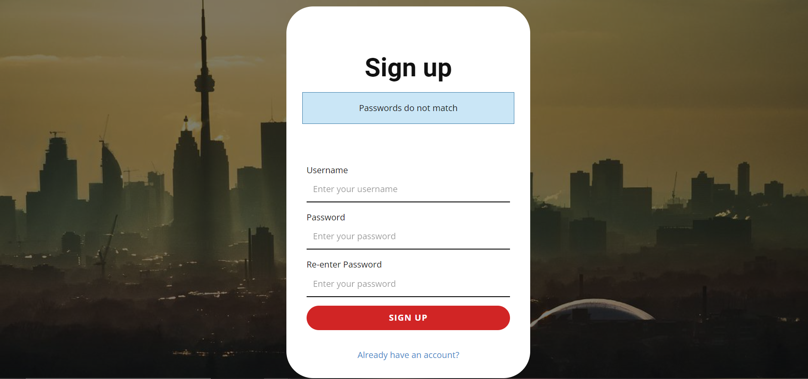

Picture (1): user enters different passwords

The image above demonstrates the reaction from the web application for when the user enters different passwords when attempting the sign up process, a flash message is displayed to inform the user of this.